Devices

1. Ethernet Switch:
2. It is intelligent. (i.e has a processor.)
3. Layer 2 device
4. Modem:

What we have at home.

1. Router:
2. Connects multiple switch
3. It is intelligent. (i.e has a processor.)
4. It is Level 3 device.
5. Hub:
6. shoting the deivces
7. Layer 1 device.

Router has many ports. Each port has a switch connected to it. Two switch can communicate with each other through router. Similarly, one switch has many ports and each port have a hub connected with it. Hubs communicate with each other through switch.

OSI Model:

Physical Layer:

Data-Link Layer:

Network Layer:

Transport layer: makes sure the message is not tampered.

Session layer: manage different session of same user. i.e. data of tab of google doesn’t show on firefox.

Presentation layer: does encryption.

Appliaction layer : application related work.

GN3

Packet Tracking

Router:

On right clicking router, we see different types of slots and ports.

There are three numbers (csp) : card/slot/port

Usually, one router has one card so they don’t mention card no.

It has three slots:

1. Fast Ethernet
2. Ethernet
3. Serial

Each slots further have their own ports.

We have to develop the below topology.

Open GNS3 software, drag and drop devices, add links, add note of ip address of networks and ports.

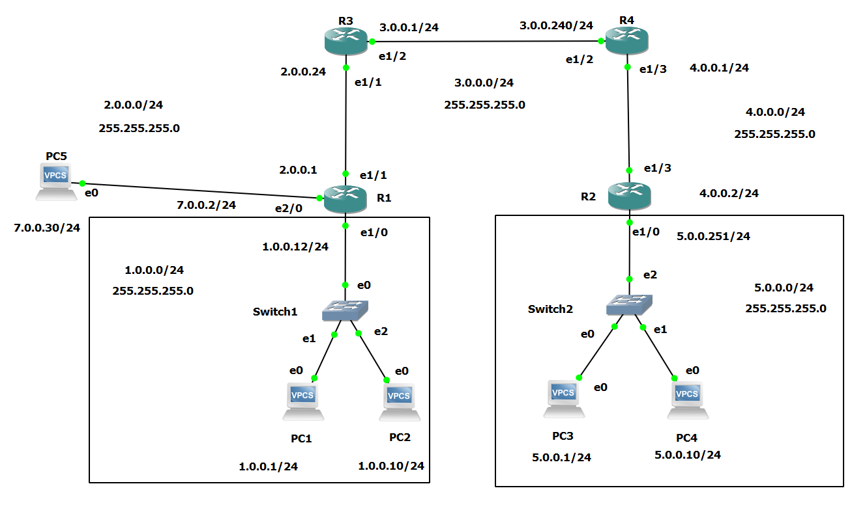

**Assign IP**

1. Open r1 console:

For Port e1/0

type:

configure terminal # to enter into configure mode

interface ethernet 1/0 # to involve port 1/0

ip address 1.0.0.12 255.255.255.0 # ip address <ip> <subnet mask>

no shutdown # to keep port running

exit

For port e1/1

Type:

interface ethernet 1/1 # to involve port 1/1

ip address 2.0.0.1 255.255.255.0 # ip address <ip> <subnet mask>

no shutdown # to keep port running

Close the terminal.

Repeat the process for:

1. Router R3
   1. e1/1
   2. e1/2
2. Router R2
   1. e1/0
   2. e1/3
3. Router R4
   1. e1/3
   2. e1/2

Now, go to each console and do verification

Type:

show ip interface brief

And check if each port is ‘UP’

**Advertise networks:**

1. R1:
   1. Go to R1 console
   2. Type:

Configure terminal

Router rip

Version 2

Network 1.0.0.0 #advertise network 1

Network 2.0.0.0 #advertise network 2

1. R2: same as r1
2. R3: same as r1
3. R4: same as r1

**Ping:**

Ping from R1 to R2 e1/

Go to r3 console:

Type:

ping 5.0.0.251 #ping <ip add of receiver>

Successful